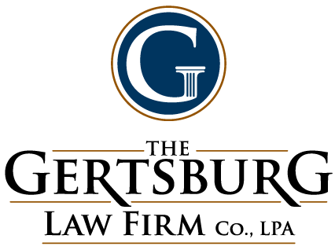

The Gertsburg Law Firm Expands Practices Areas with Experienced Attorneys

Cleveland, Ohio (February 21, 2017) – The Gertsburg Law Firm is pleased to welcome three experienced attorneys to the firm – Nate Haskell, Ryan Sears and Mark Turner. Combined, these attorneys bring more than 35 years of legal expertise, including business transactions, litigation and criminal defense, to the firm’s clients.

Nate Haskell, Senior Counsel
Haskell brings over 10 years experience advising organizations in business transactions and disputes to the firm. Previously, Haskell served as in-house counsel for FirstEnergy Corp advising business units on governance, compliance and disclosure issues. His expertise also spans a combined eight years representing banks, middle market businesses, private equity firms, and public companies in business transactions and compliance matters. With experience representing businesses as outside counsel and in-house, clients benefit from a results-based approach to resolving legal issues.

Ryan Sears, Senior Counsel
Sears has joined the firm with more than a decade of experience working for both the United States Navy JAG Corps and a civil litigation boutique law firm. Utilizing his years of experience prosecuting and defending criminal matters, Sears heads up the firm’s criminal defense practice. He also has expertise in the defense of service members facing administrative and criminal disciplinary proceedings, having served as a senior trial counsel, senior defense counsel, and Special Assistant U.S. Attorney while in the military.

Mark Turner, Senior Counsel
Turner comes to the firm after 13 years as a litigator at Gallagher Sharp. Before becoming an attorney, he served as a financial manager for a small business after earning his MBA. He has represented a diverse array of clients and successfully litigated matters ranging from small business disputes to class actions. Turner’s extensive legal and business background results in a proactive approach to law – finding cost-effective solutions rather than spending valuable resources to win at all costs. His practice includes litigation, business advising, nonprofit consulting and probate.

About the Gertsburg Law Firm
The Gertsburg Law Firm is changing the character of the attorney-client relationship in business from a cost-center to a trusted advisor. Drawing from their complex litigation experiences as members of large law firms, in-house counsel and federal attorneys, the Gertsburg Law Firm’s award-winning attorneys provide clients the benefit of business lawyers with real life business experience in a wide variety of industries. This dynamic results in a comprehensive and innovative approach to business law that is proactive and consultative, ultimately saving clients money in fees and exposure before issues arise. Located in Chagrin Falls, Ohio, the Gertsburg team of lawyers and support staff leverages its knowledge, broad experience and steadfast dedication to both solving and avoiding clients’ business problems, and helping them actually grow their businesses in a way that no other law firm does.

# # #

